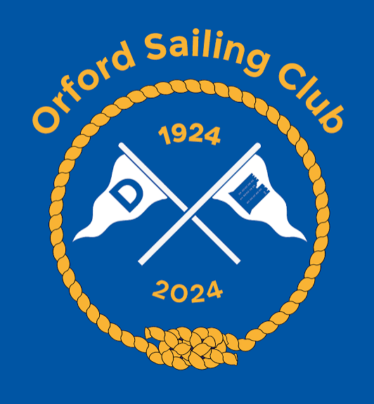

Orford Sailing Club Centenary Fund Donation Form

Please complete this form and return it to Orford Sailing Club. Email: Honsec@orfordsail.org.uk or Post 15 Wye Close, Bletchley, Milton Keynes, MK3 7PJ Thank you for helping secure the Club’s next century on the water.

1. Your Details
Full name
Address
Postcode
Email
Phone

2. Donation Options

Regular Giving — Friend of OSC
☐ | £10 per month | ☐ | £20 per month
☐ | £50 per month | ☐ | £100 per month
☐ | Other amount: £__________ per month

Legacy Gift — Include OSC in Your Will
☐ | £500 | ☐ | £1,000
☐ | Other amount: £__________
☐ | Please contact me about leaving a legacy gift to Orford Sailing Club

One-Off Donation
☐ | £500 | ☐ | £1,000
☐ | Other amount: £__________

3. Payment Details
☐ | I have set up a standing order with my bank
☐ | I enclose a cheque payable to Orford Sailing Club Centenary Fund
☐ | Please contact me to arrange payment
Bank name | Barclays Bank
Account holder | Orford Sailing Club
Sort code | 20 / 98/ 07
Account number | 40677124

Signature: ________________________________
Date: _____________________________________

Thank You
Your support helps Orford Sailing Club encourage young sailors, widen access to the river, care for Club facilities and protect sailing in Orford for future generations.

